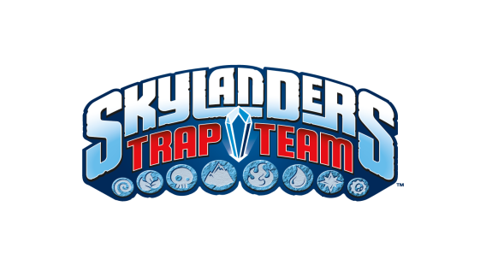
FACT SHEET

PRODUCT DESCRIPTION:
Skylanders® is redefining the Toys to LifeTM phenomenon with yet another ground-breaking innovation, Skylanders Trap TeamTM. In previous Skylanders games, we brought physical toys to life inside the game. With Skylanders Trap Team, we are reversing the magic by bringing characters out of the game, into physical “Traps” that kids can take with them, effectively bringing Life to Toys.

In Skylanders Trap Team, Kaos continues his ongoing quest to rule over Skylands. He has discovered the location of the legendary Cloudcracker Prison -- a fortress built entirely out of the magical substance TraptaniumTM and home to Skylands’ most nefarious baddies. In an attempt to build his own army of foes, Kaos blows up the prison, releasing the most wanted villains and blasting shards of Traptanium to Earth in the form of Traps. Now it’s up to Portal Masters to recapture all of the escaped villains using powerful Traptanium Traps and defeat Kaos before it’s too late!

Skylanders Trap Team introduces a ground-breaking innovation that lets Portal Masters “trap” the most wanted villains in Skylands and then play as them in the game in the battle for good. The game offers an unprecedented new addition to the game’s play pattern in the form of Traptanium Traps. When this new type of toy is placed directly into the Traptanium PortalTM, Portal Masters can “capture” a variety of special villains from the game and magically transport them from Skylands into the real world.

KEY FEATURES:
- Toys to Life, Life to Toys – Players will experience an exciting new level of Skylanders innovation through the Traptanium Portal, a new ring of magical energy which reverses the magic of the toys to life category by letting players bring digital characters into the physical world. A built-in audio speaker allows players to magically hear the unique voices of the villains travel from the game into the real world Trap, and vice versa. The Trap also lights up in sync with the villain speaking, adding even more magic to the experience. If you look closely, you can almost see the villain trying to escape from inside the Trap.

- Two Ways to Play – In Skylanders Trap Team, you can play as a Skylander or capture Skylands’ most wanted foes and unleash them for good. It’s up to Portal Masters to find these villains and capture them inside the new Traps that transport the villains into the real world via the Traptanium Portal. Once trapped, players can return the villain to Skylands as a playable character. This exciting new play pattern gives fans the option to switch between playing as a Skylander hero or a villain at any time, creating fun and unique “tag team” gameplay.

- Elementally Designed Traps – Themed Trap designs add variety to the collectible Skylanders Trap Team experience. Each Trap is elementally aligned, letting players capture villains who fall under that element. For instance, when Portal Masters explore the world of Skylands and encounter a water villain, they can insert a water Trap into the Traptanium Portal to capture that villain, as well as bring that villain back into Skylands as a playable character who helps in the fight for good. If players don’t have the correct Trap for a villain they encounter, the defeated villain will be held in a Villain Vault, where Portal Masters can keep track of the foes they have captured. When the player buys the correct Trap, they can transfer the villain from the Vault into the Trap in order to play as him. With each new Trap added to their collection, Portal Masters unlock an exciting world of possibilities!

- New Cast of Characters –A brand new group of Skylanders, known as Trap Masters, lead the charge armed with their oversized crystal weapons in the fight against the most wanted villains and returning nemesis Kaos. The game introduces more than 50 new playable Skylanders heroes, including:
    - New Trap Master Skylanders
    - New Core Skylanders
    - Reposed, fan-favorite Skylanders

- Exciting New Adventure – Skylanders Trap Team features an all new adventure-filled story with fun and interesting new characters as well as returning franchise favorites. The game delivers a diverse and dynamic, story-driven gameplay experience, filled with adventure, combat, puzzles, mini games, activities, platforming, and drop-in/drop-out co-op play -- all set within a variety of new compelling environments. With each new addition to their Trap Team collection, Portal Masters unlock exciting new gameplay possibilities within each level. Seasoned fans can play Skylanders Trap Team with their entire collection of 175 forward compatible characters from Skylanders SWAP ForceTM, Skylanders GiantsTM and Skylanders Spyro’s Adventure®.

Publisher: Activision Publishing, Inc.
Developers: Toys for Bob (Xbox 360, PlayStation 3, Wii)
Beenox (Xbox One, PlayStation 4, Wii U, 3DS)

Platforms: Nintendo Wii™, Wii U™, 3DS™
Xbox 360™ and Xbox One™ video game and entertainment system from Microsoft
PlayStation®3 and PlayStation®4 computer entertainment system

Release Date: October 5, 2014 (North America), October 10, 2014 (EU)
October 2, 2014 (APAC)

MSRP: $74.99 – Skylanders Trap Team Starter Pack
$14.99 – Individual Trap Master action figure
$9.99 – Individual Core Skylanders action figure
$5.99 - Individual Trap toy

ESRB Rating: E10+

PR Contact Info: Michele Wyman Dior Brown
PMK•BNC Activision Publishing
310.854.3264 424.744.5864
michele.wyman@pmkbnc.com dior.brown@activision.com

