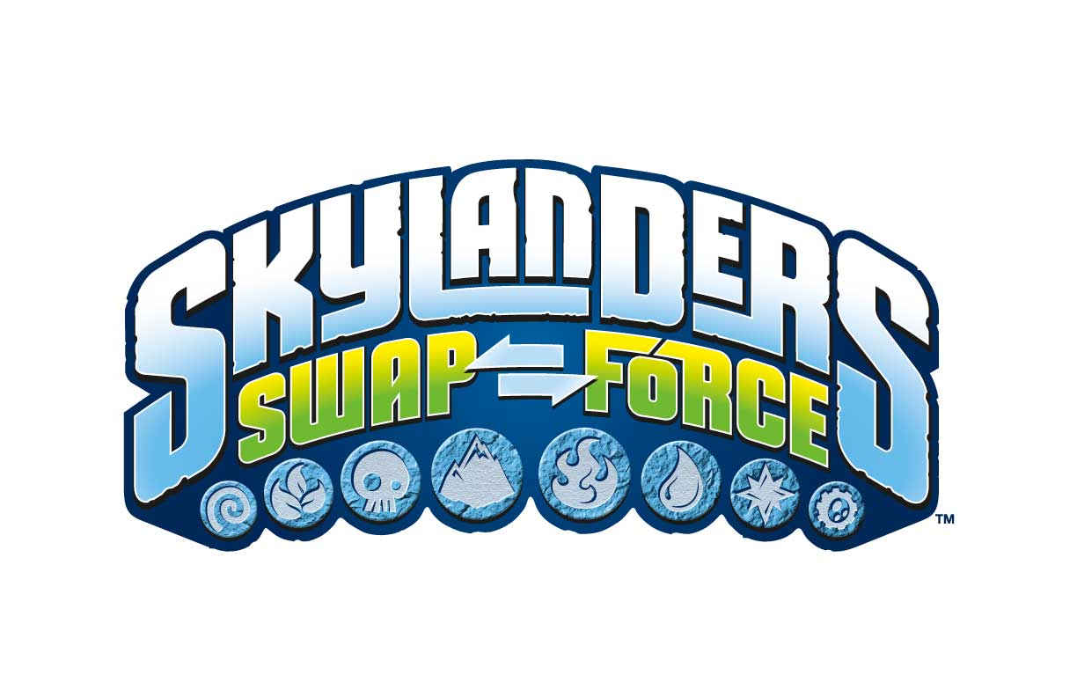

FACT SHEET
PRODUCT DESCRIPTION:
Skylanders is “mixing it up” with the newest game in the award-winning, top-selling franchise. Skylanders SWAP Force builds upon the success of the franchise’s signature gameplay and collectible toy experience, adding an all-new dimension to the “toys to life” innovation. The game introduces a compelling play pattern -- swapability -- that lets gamers transform 16 SWAP Force inter-action figures into more than 250 unique characters by swapping the top and bottom halves of the toys. Now, Portal Masters can mix and match characters’ powers and moves and experience an unprecedented level of choice never before seen in a SkylandersTM game. Fans also can play Skylanders SWAP Force with their entire collection of 100+ characters from Skylanders Spyro’s Adventure® and Skylanders GiantsTM.

Skylanders SWAP Force features new abilities – such as flying, climbing, digging, bouncing, or teleporting – which can be used in previously unexplored areas of Skylands centered on these play mechanics. Additionally, the game features 16 new core characters, eight new LightCore™ characters and 16 new versions of fan favorite Skylanders from previous games. Now kids will have more than 100 characters from which to choose. The game’s high-resolution graphics brings detailed characters and richer environments to life, immersing players in the game like never before.

In Skylanders SWAP Force, Portal Masters embark on an all new adventure in the mysterious Cloudbreak Islands, home to a mystical volcano that erupts every hundred years to replenish the magic in Skylands. During an epic battle, a brave group of Skylanders were caught in the volcano’s eruption, which blasted them apart and sent them to earth. But, the magic of the volcano gave these heroes a remarkable new power -- the ability to swap halves – turning them into a special team known as the SWAP Force. Meanwhile, Kaos is back with a new evil plan. And now, Portal Masters everywhere must reassemble the SWAP Force -- in their original form or in new combinations -- and send them back to Cloudbreak to save Skylands!

KEY FEATURES:
  - Swapability – Skylanders SWAP Force features 16 new SWAP Force inter-action figures with new powers and a fresh play pattern – swapability – that lets kids create more than 250 unique character combinations, giving them more choice than ever before over how they fight and move in the game. With each new addition to their Skylanders SWAP Force collection, Portal Masters unlock an exciting world of possibilities.

- Gameplay Variety – Skylanders SWAP Force delivers a diverse and dynamic, story-driven gameplay experience, filled with adventure, combat, puzzles, mini games, activities, platforming, traps & hazards and drop-in/drop-out co-op play -- all set within compelling environments. With each new addition to their SWAP Force collection, Portal Masters unlock exciting new possibilities. Seasoned fans can play Skylanders SWAP Force with their entire collection of 100+ forward compatible characters from Skylanders Spyro’s Adventure and Skylanders Giants. Plus, the level cap has been raised to 20 for all Skylanders characters, including legacy characters. Additionally, based on fan demand, all Skylanders now have the ability to jump.
  - All-New Characters – More than 50 collectible characters including 32 never-before-seen Skylanders heroes each with unique powers and personalities:
    - 16 new SWAP Force characters
    - 16 new Core Skylanders characters
    - 8 LightCore™ Skylanders characters
    - 16 new versions of fan-favorite Skylanders from the previous games, each featuring an all new “Wow Pow” upgrade power
  - Exciting Adventure – Portal Masters will embark on a brand new adventure, encountering never-before-seen enemies and challenges, as well as meeting memorable non-playable characters who can help the Skylanders defeat Kaos and his minions in the Cloudbreak Islands.
  - Unique SWAP Force Zones – Skylanders SWAP Force characters feature new abilities – such as flying, climbing, digging, bouncing, or teleporting – each of which can be explored in new areas of Skylands.
  - Assortment of Gameplay Modes – Players can experience various Survival and Battle Modes, all featuring vibrant, action-packed arenas and environments where Portal Masters can test the true strength of their Skylanders.
    - Solo Survival Mode – Single player horde style mode where players must battle through waves of enemies
    - Team Survival Mode – Two-player co-op horde style mode where a team must battle through waves of enemies
    - Rival Mode – Two-player “versus” mode where both players must fend off waves of enemies; the player with the higher score wins
    - Battle Arena Mode – Player vs. player-style mode that lets Portal Masters pit their Skylanders against each other
    - Ring Out Mode – Players must fight to knock their opponents out of the battle arena
  - Enhanced Graphics Quality – Console versions of Skylanders SWAP Force feature high-resolution graphics that bring to life amazingly detailed characters and richer environments to deliver a high level of visual fidelity that immerse players in the game like never before.

Publisher: Activision Publishing, Inc.
Developers: Vicarious Visions (Wii U, Xbox 360, Xbox One, PlayStation 3, PlayStation 4)
Beenox (Wii)
n-Space (3DS)
Platforms: Nintendo Wii™, Wii U™, 3DS™
Xbox 360™ and Xbox One™ video game and entertainment system from Microsoft
PlayStation®3 and PlayStation®4 computer entertainment system

SRP: $74.99 - Skylanders SWAP Force starter pack
$14.99 - individual SWAP Force action figure
$9.99 - individual core Skylanders action figure

Release Date: Oct. 13, 2013 - North America; Oct.16, 2013 - Australia; Oct. 18, 2013 - Europe

ESRB Rating: E10+ for Cartoon Violence

PR Contact Info: Michele Wyman Dior Brown
PMK•BNC Activision Publishing
310.854.3264 424.744.5864
michele.wyman@pmkbnc.com dior.brown@activision.com

# # #

