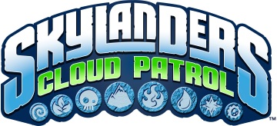
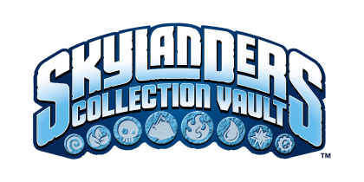
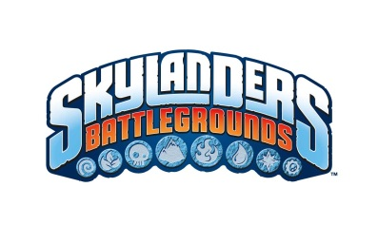

SKYLANDERS MOBILE FACT SHEET

SKYLANDERS BATTLEGROUNDS™:
Skylanders Battlegrounds notches another first for the Skylanders franchise by bringing its signature blend of physical and virtual play from the console experience to mobile devices. The Skylanders Battlegrounds Starter Pack includes a special wireless Bluetooth Portal of Power® that brings your figures to life on iOS, and three Skylanders: Jet Vac, Series 2 Cynder and Double Trouble, and a Platinum Treasure Chest stocked with digital items for use in Skylanders Battlegrounds.

KEY FEATURES:

- An exciting Action RPG experience designed from the ground up for mobile devices, featuring innovative team-up gameplay in which the player controls two Skylanders at the same time.

- Episodic content, starting with two chapters containing 20 levels and two mega bosses upon initial release. Two additional chapters with 20 new levels and two new bosses were released in 2013 through in-app updates, which are free for existing players.

- Players who purchase the Skylanders Battlegrounds Starter Pack get to use the platinum treasure chest that automatically unlocks loads of in-game loot including a coin and XP multiplier, health potions, bombs, and much more.

- Skylanders Battlegrounds has been updated with every new character from the latest console game, Skylanders SWAP Force.

SKYLANDERS LOST ISLANDS™
An innovative character and resource management game, Skylanders Lost Islands gives Portal Masters a chance to rebuild and customize their own slice of the Skylands. Players can play with their Skylanders by sending them off on quests and adventures, using them to ward off evil trolls, and chase away pesky sheep all while helping the peaceful Mabu rebuild their homeland in the sky.

KEY FEATURES:

- Players can build and grow their own magical community in Skylands by cultivating powerful elemental crops to enhance and upgrade their town.

- Portal Masters who interact with their friends through Skylanders Lost Islands can earn special in-game items and rewards.

- Skylanders Lost Islands features a code entry system that allows collectors to enter their unique codes located on each toy to unlock the characters in the game. Players can also use the Bluetooth Portal of Power® to unlock their Skylanders.

- Skylanders Lost Islands has been updated with every new character from the latest console game, Skylanders SWAP Force.

SKYLANDERS CLOUD PATROL™
Skylanders Cloud Patrol is set in a new region of Skylands that has been overrun by the evil minions of Kaos. The game lets players take command of a magnificent sky-ship and use their favorite Skylander to dispatch the baddies using touch gestures to tap-and-shoot or swipe the screen to create amazing combos.

KEY FEATURES:

- Skylanders Cloud Patrol lets fans unlock Skylanders and Magic Items and bring them to life in the game using the unique code bundled with each Skylanders action figure or by using the Bluetooth Portal of Power.

- New Portal Masters may earn or purchase in-game currency to build their virtual mobile Skylanders collection, housing and community buildings, decorations and more.

- Skylanders Cloud Patrol also features Game Center and Google Play leaderboards and achievements, as well as a 3D character viewer that allows players to browse their entire in-game collection.

- Skylanders Cloud Patrol lets players challenge their friends to a Showdown, send them challenges via push notifications and beat them to earn in-game currency.

SKYLANDERS COLLECTION VAULT™
Skylanders Collection Vault lets players easily manage their Skylanders toy collection and explore new Skylanders toys from the palm of their hands and on the go. For the first time via the Skylanders Collection Vault app, Portal Masters can discover the Skylanders and learn more about their backstories all in one place. Optimized for tablet and mobile devices, the app also allows fans to keep track of their Skylanders collection and their wish list, browse images and videos, unlock special content and challenge their friends to see who has the most robust collection.

KEY FEATURES:

- Skylanders fans can discover heroes in the Skylanders universe, including image galleries, videos, stats and backstories.

- Players can add each of their owned Skylanders to their collection and increase their Portal Master ranking.

- Portal Masters can challenge their friends to see who has the strongest collection via the Skylanders Collection Vault Battle Mode

- The Skylanders Collection Vault Wish List lets fans build and share a list of each Skylander they would like to add to their collection.

Publisher: Activision Publishing, Inc.

Developers: Vicarious Visions (Skylanders Battlegrounds, Skylanders Lost Islands and Skylanders Cloud Patrol)
AKQA (Skylanders Collection Vault)

Platforms: Skylanders Battlegrounds: iOS, Android
Skylanders Lost Islands: iOS, Android
Skylanders Cloud Patrol: iOS, Android, Kindle Fire
Skylanders Collection Vault: iOS

SRP: Skylanders Battlegrounds: $6.99 + Microtransactions
Skylanders Lost Islands: Free + Microtransactions
Skylanders Cloud Patrol: $1.99 + Microtransactions
Skylanders Collection Vault: Free

Release Date: Skylanders Battlegrounds: November 21, 2012
Skylanders Lost Islands: November 6, 2012
Skylanders Cloud Patrol: March 29, 2012
Skylanders Collection Vault: November 26, 2013

PR Contact Info: Michele Wyman Dior Brown
PMK•BNC Activision Publishing, Inc.
310.854.3264 424.744.5864
michele.wyman@pmkbnc.com dior.brown@activision.com

# # #

