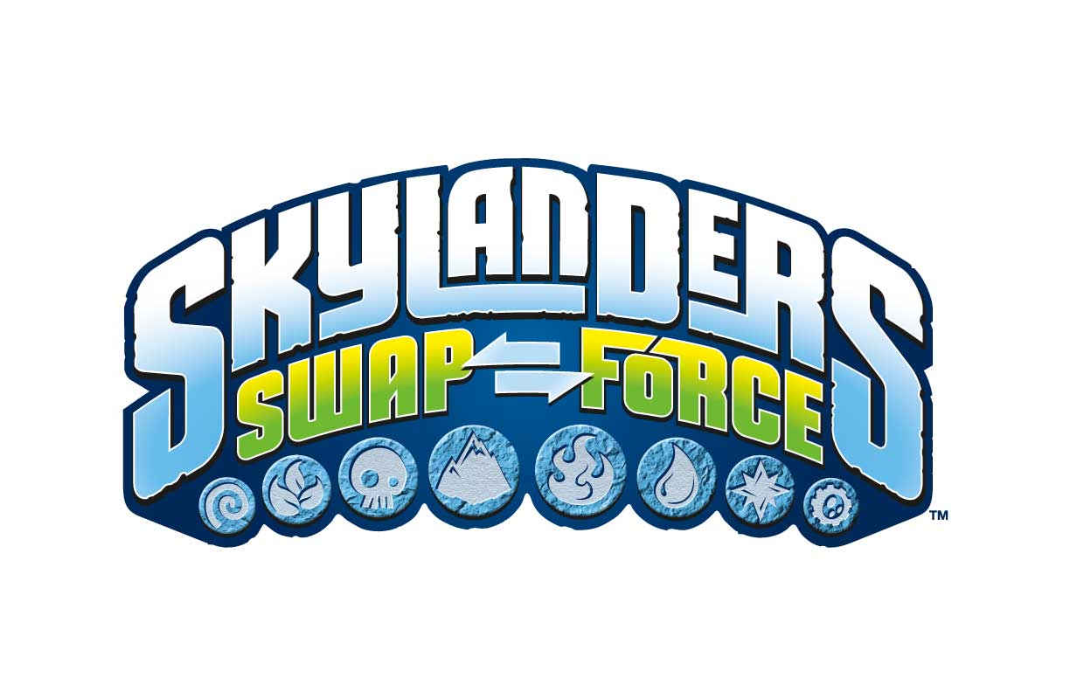

** MEDIA ALERT ** MEDIA ALERT ** MEDIA ALERT **

Skylanders SWAP FORCE takes over Times Square for “SWAPtoberfest” Celebration

Portal Masters are Invited to a Special Event on Thursday, SWAPtober 10th
for an Advance Look at the Highly Anticipated Game Skylanders SWAP Force™

WHAT: Activision Publishing, Inc., brings the world of Skylands to life for one special day in Times Square to celebrate the upcoming launch of Skylanders SWAP Force. The makers of the Skylanders® franchise -- one of the world’s most successful video game franchises¹ -- is inviting fans to experience the world of Skylands during the “SWAPtoberfest” event.

Kids who visit Times Square on SWAPtober 10th can participate in the “SWAPtoberfest” themed activities. Select Skylanders costumed characters will attend and Skylanders-branded prizes will be given away (while supplies last) at the event to fans. Portal Masters will also have the opportunity to win a Skylanders SWAP Force Starter Pack, as well as play the game in advance of its official launch.

Adding to the excitement, actor James Marsden (“Anchorman 2”) will host the event and join emcee Zach Gordon (“Diary of a Wimpy Kid,” “Pete's Christmas”) for the free and open to the public event.

WHO: James Marsden (“Anchorman 2”) and Zachary Gordon (Diary of a Wimpy Kid) joins Skylanders costumed characters, kids, teens, parents and video game fans

WHEN: Thursday, Oct. 10 from 3– 6 p.m.

WHERE: 44/45 Pedestrian Plaza, Times Square

Adjacent to Toys“R”Us Times Square

1514 Broadway (at 44th Street), New York, NY 10036

WHY: Skylanders SWAP Force will be available in North America on Xbox 360™, PlayStation® 3, Nintendo Wii™, Nintendo Wii U™ and Nintendo 3DS™ on October 13, in Australia on October 16 and in Europe on October 18. It also will be available day and date with the launch of Xbox One™ and PlayStation® 4.

VISUALS:
- James Marsden handing out the first Skylanders SWAP Force starter pack to a lucky kid
- Crowds gathering to celebrate “SWAPtoberfest” in Times Square
- Visitors participating in the interactive SWAP Force-themed activities
- Parents and kids experiencing the life-sized world of Skylands
- Skylanders SWAP Force game footage featured on the Jumbotron that fans and passersby can watch
- B-roll and photos available

¹ Based on revenue, according to The NPD Group, Gfk Media Control® and Activision internal estimates, including toys and accessory packs.

For information and to request an interview, please contact:
Katie Harris-Maines
PMK*BNC, On Behalf of Activision, Publishing, Inc.
310-854-4856 (office)
310-689-8930 (cell)
Katie.Harris@pmkbnc.com

# # #

