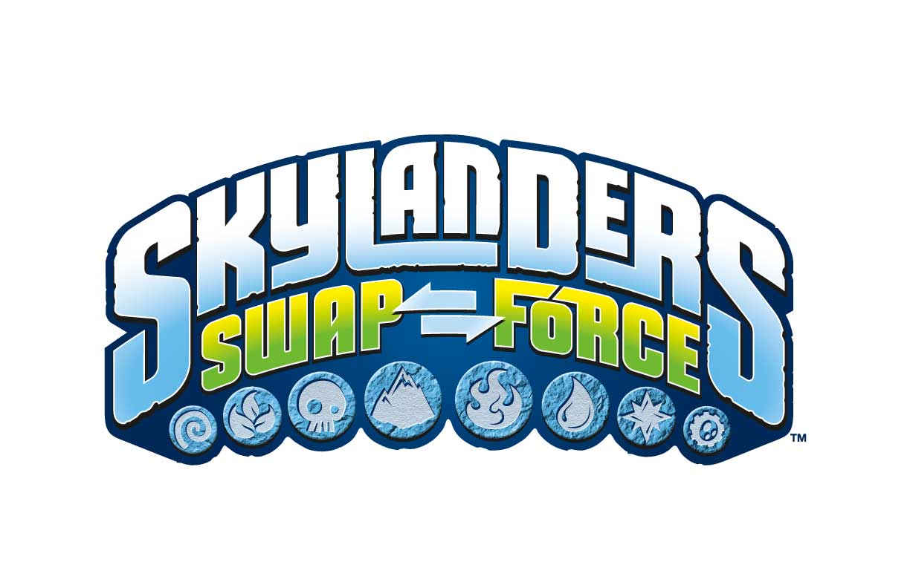

Skylanders SWAP FORCETM takes over Times Square for “SWAPtoberfest” Celebration

Portal Masters Attended a Special Event on Thursday, SWAPtober 10th
for an Advance Look at the Highly Anticipated Game Skylanders SWAP Force

Santa Monica, CA – Oct. 10, 2013 – In celebration of its upcoming launch of
Skylanders® SWAP Force™ on October 13, 2013, Activision Publishing, Inc., today
brought the world of Skylands to life for one special day in Times Square and invited fans
to participate in the “SWAPtoberfest” event.

Kids who visited Times Square on SWAPtober 10th had the chance to be among the very first to play the game before it's available at retail this coming Sunday. SWAPtoberfest featured Skylanders SWAP Force-themed activities, photos with Skylanders® costumed characters as well as chances to win a Skylanders SWAP Force Starter Pack and special Skylanders-themed merchandise. Adding to the excitement, actor James Marsden (“Anchorman 2”) hosted the event and joined emcee Zach Gordon (“Diary of a Wimpy Kid,” “Pete's Christmas”) for the event.

Available for Nintendo Wii, Nintendo Wii U, Nintendo 3DS, Xbox 360, PlayStation 3 on October 13 and day-and-date for PlayStation 4 and Xbox One, Skylanders SWAP Force introduces an all new innovative play pattern – swapability - that lets gamers reconfigure the top and bottom halves of 16 new SWAP ForceTM characters by mixing and matching their powers and moves into more than 250 unique combinations¹, and then bring them to life in the game.

Skylanders SWAP Force pushes the boundaries of imagination and gives kids more choice than ever before over how they fight and move. Set in a richly detailed world, the game takes kids on an all-new adventure with more than 30 new collectible characters each with unique powers and personalities -- 16 new SWAP Force characters, 16 core Skylanders characters and eight new LightCore® characters. Additionally, fans can play Skylanders SWAP Force with their entire collection of 100+ characters from Skylanders Spyro’s Adventure® and Skylanders GiantsTM.

Skylanders SWAP Force features high-resolution graphics² that bring the game’s detailed characters and rich environments to life like never before. The game also features new abilities – such as flying, climbing, and teleporting – which can be used throughout Skylands. Friends and family can join the fun with drop-in/drop-out cooperative play, and an all new Battle Mode and Survival mode arenas.

To access broadcast quality video, online quality video and photos, please click here.

About Activision Publishing
Headquartered in Santa Monica, California, Activision Publishing, Inc. is a leading worldwide developer, publisher and distributor of interactive entertainment and leisure products. Activision maintains operations in the U.S., Canada, Brazil, Mexico, the United Kingdom, France, Germany, Ireland, Italy, Sweden, Spain, Denmark, the Netherlands, Australia, Singapore, mainland China, Hong Kong and the region of Taiwan. More information about Activision and its products can be found on the company’s website, www.activision.com.

¹Requires purchase of all 16 SWAP Force Skylanders.
²High resolution graphics not available on Nintendo Wii and Nintendo 3DS.

For information and to request an interview, please contact:
Katie Harris-Maines
PMK*BNC, On Behalf of Activision, Publishing, Inc.
310-854-4856 (office)
310-689-8930 (cell)
Katie.Harris@pmkbnc.com

# # #

