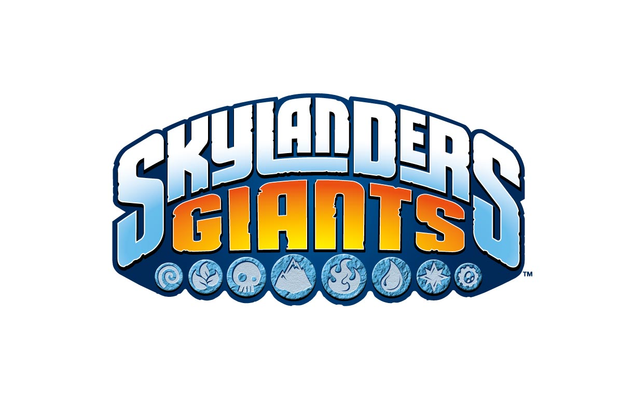
CHARACTER BIOS

For Reference Only

GIANTS (Revealed as-of August 2012)
Bouncer
Deal with the Wheel!
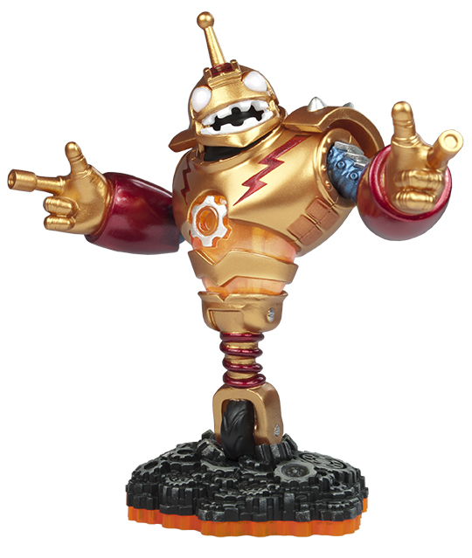
Element: Tech
Character Type: Giant
Bio: Long ago, Bouncer was an All-Star Roboto Ball player. His big, lively personality helped popularize the sport, but after taking too many hits to the head, he retired and the sport faded away. Bouncer then became a security-bot in the Crystal Mines. It was there he encountered dozens of Mabu from his Roboto Ball fan club that had been enslaved by the Arkeyans. Not wanting to let his fans down, Bouncer came out of retirement and began shooting at a new goal – defeating the Arkeyan King. Soon after he teamed up with other Giants, and together they became the first Skylanders.

CRUSHER
It’s Crush Hour!
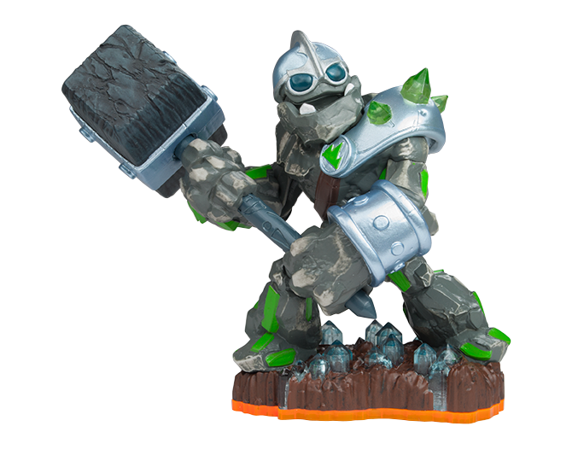
Element: Earth
Character Type: Giant
Bio: Crusher knew from the moment he put on his father’s mining helmet that his true passion in life was crushing rocks. He was fascinated with rock-lore and traveled all throughout Skylands in search of rare minerals to pulverize with his powerful hand-crafted rock hammer, which he also named Crusher. But along his travels, he discovered that the evil Arkeyan King was also searching for rocks – to melt down into weapons of war. Crusher’s fury built up like an avalanche. After all, crushing was his job! So he put aside his life’s passion and decided to use his hammer for a greater purpose - crushing Arkeyan Robots!

SWARM
Bring the Sting!
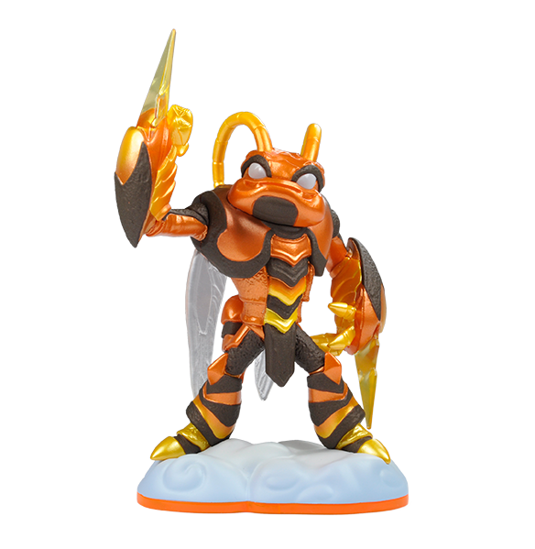
Element: AIR
Character Type: Giant
Bio: Swarm was once a prince from a proud race of mysterious insect warriors that had built their entire civilization inside a giant honeycombed pyramid. Growing up as one of the 9,000 members of the royal family, he was never permitted to leave the hive. But unlike his brethren, there was a magical quality to Swarm that caused him to grow much larger than the rest of his kind. No longer able to fit amongst the rest of his colony, the young prince broke the long standing tradition and stepped out into the open world – where his size and strength would be put to good use in the legendary battle between the Giants and the Arkeyans.

Tree Rex
Be Afraid of the Bark!
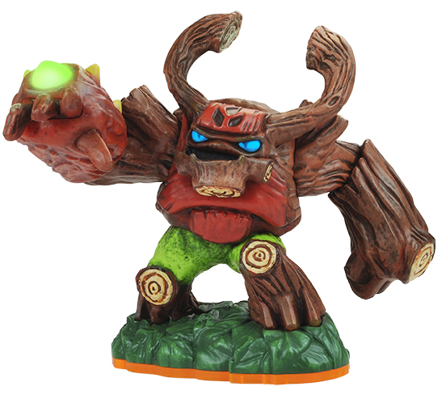
Element: Life
Character Type: Giant
Bio: Long before the Giants protected Skylands, Tree Rex was a majestic tree living peacefully in the ancient woods. But this tranquil existence came to an end when the Arkeyans built a nearby factory to produce war machines. After years of his soil being poisoned by the magic and tech waste from the factory, he mutated into who he is now – a powerful Giant who will crush anything that threatens the natural order of things.

NEW SKYLANDERS (Revealed as-of August 2012)
CHILL
Stay Cool!
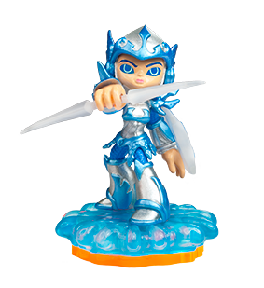
Element: WATER
Character Type: New Skylander
Bio: Chill was the sworn guardian and personal protector of the Snow Queen. As captain of the queen’s guard, her many heroic deeds had earned her the respect of the entire Ice Kingdom. But when the Cyclops army began to expand their empire into the northern realms, the Snow Queen was taken prisoner during her watch, and Chill has never forgiven herself for letting it happen. Ashamed and embarrassed, she left the Ice Kingdom behind and swore never to return until she could reclaim her honor. Now as a member of the Skylanders, she remains courageous and strong, while always on the lookout for her lost queen.
FRIGHT RIDER
Fear the Spear!
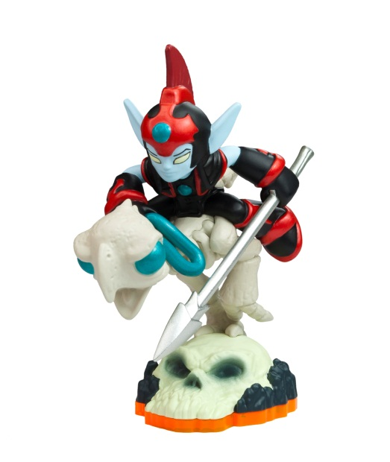
Element: UNDEAD
Character Type: New Skylander
Bio: Rider and his magnificent ostrich, Fright, were the finest jousting team in all of Skylands. But after winning the championship for the 3rd straight year, a jealous competitor placed a curse on the elf that sent him to the Land of the Undead. Not wanting to be without his partner, Fright, who up until this point had been afraid of nearly everything, ate a bag of skele-oats that turned him into a skeleton so that he could brave the journey to the underworld to save his friend. Grateful for being rescued, Fright Rider returned to the surface dedicated to helping others – while still dominating an occasional jousting tournament from time to time!
Jet-Vac
Hawk And Awe!
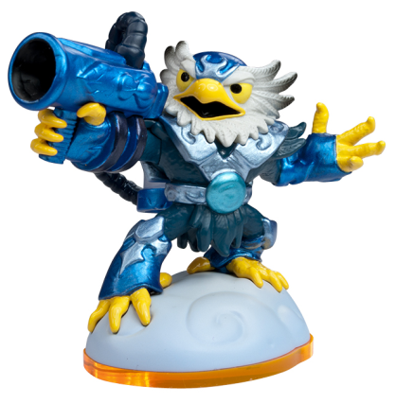
Element: Air
Character Type: New Skylander
Bio: Jet-Vac was the greatest, most daring flying ace in all of Windham. He was given his magical wings when he was young, as was the tradition for all Sky Barons. But when his homeland was raided, he chose to sacrifice his wings to a young mother so she could fly her children to safety. This act of nobility caught the attention of Master Eon, who sought out the young Sky Baron and presented him with a gift – a powerful vacuum device that would allow him to soar through the skies once again. Jet-Vac accepted the gift with gratitude, and now daringly fights evil alongside the other Skylanders.
Pop Fizz
Motion of the Potion!
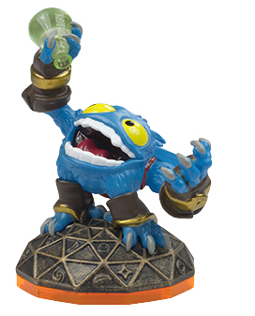
Element: Magic
Character Type: New Skylander
Bio: Nobody is quite sure who Pop Fizz was before he became an alchemist, least of all Pop Fizz himself. After many years of experimenting with magical potions, his appearance has changed quite significantly. In fact, no one even knows his original color. But it’s widely known that he is a little crazy, his experiments are reckless, and the accidents they cause are too numerous to measure. Understandably, he has had a difficult time finding lab partners, or anyone that even wants to be near him. In hopes of making himself more appealing to others, he attempted to create the most effective charm potion ever – but that just turned him into a big, wild, berserker. Or maybe that’s just how he saw the potion working in the first place…
SHROOMBOOM
He Shoots, He Spores!
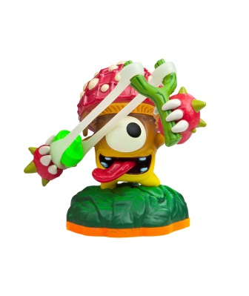
Element: Life
Character Type: New Skylander
Bio: Shroomboom was most unfortunate to have been born in a pizza topping garden belonging to Kaos. Growing up among his fellow fungi, he knew it was only a matter of time before a late night craving would bring about their demise. So Shroomboom took a twig and a strand of spider web and made a slingshot. One by one, he launched all of his friends over the garden fence before flinging himself over to join them. Then he guided them all to the edge of the island and leapt to freedom, using his mushroom cap to catch a friendly breeze. Now as a member of the Skylanders, Shroomboom continues to perform courageous deeds… but he can be hard to find on pizza night.

SERIES 2 (Revealed as-of August 2012)
Chop Chop

Slice And Dice!
Element: Undead
Character Type: Series 2

Bio: Chop Chop was once an elite warrior belonging to the ancient race of Arkeyan beings. Like many of the Arkeyans, he was created from a hybrid of elements - in his case, undead magic and technology. Chop Chop is a relentless, highly-skilled solider who wields a sword and shield made of an indestructible metal. With the Arkeyans having vanished long ago, Chop Chop wandered Skylands for centuries looking for his creators. Eventually, he was found by Eon and recruited as a Skylander.
Cynder
Volts and Lightning!
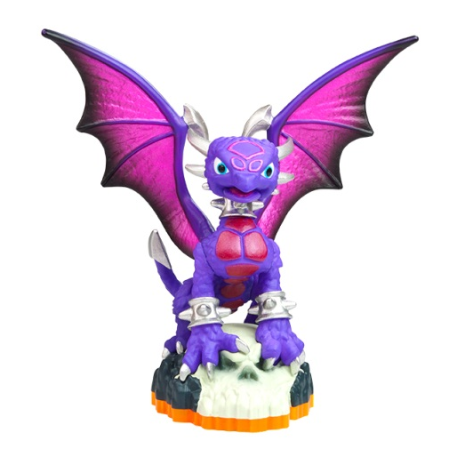
Element: Undead
Character Type: Series 2
Bio: While just an egg, Cynder was stolen by the henchmen of an evil dragon named Malefor and trained to do his bidding. For years, she spread fear throughout the land until she was freed from the grip of the evil dragon. Having shown a desire to fight for good, Master Eon made Cynder a Skylander. But dark powers still flow through her, and despite her commitment to make amends for the past, most Skylanders try to keep a safe distance… just in case.

Ignitor

Slash And Burn!
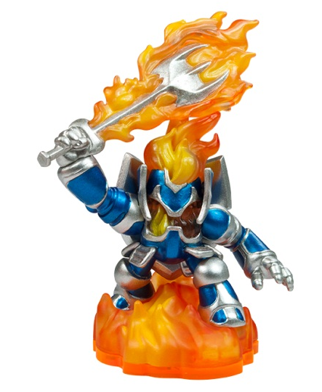
Element: Fire

Character Type: Series 2

Bio: On his first quest as a knight, Ignitor was tricked by a cunning witch into wearing a magical suit of armor that he was told would resist fire from a dragon. But as it turned out, it was made of cursed steel. He journeyed to a dragon’s lair where a single blast of fire transformed him into a blazing spirit, binding him to the suit of armor for eternity. Despite this setback, Ignitor remains a spirited knight who is always fired up to protect Skylands from evil… and find the witch that tricked him.
Slam Bam

Armed And Dangerous!
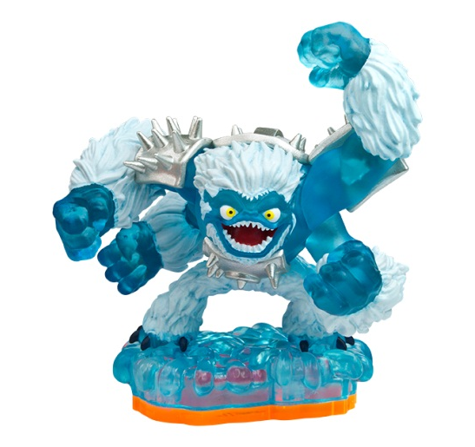
Element: Water

Character Type: Series 2

Bio: Slam Bam lived alone on a floating glacier in a remote region of Skylands, where he spent his time ice surfing, eating snow cones, and sculpting amazing ice statues. It was a peaceful life, until Kaos destroyed the glacier, stranding Slam Bam on an iceberg that drifted through the skies for days. He awoke on Eon’s Island, where he was taken in and trained to become a Skylander. Now his ice sculptures serve as a frosty prison for any evil-doer that gets in his way.
Terrafin

It's Feeding Time!
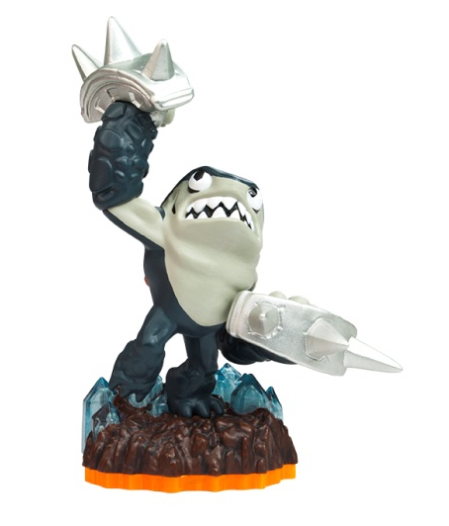
Element: Earth
Character Type: Series 2

Bio: Terrafin hails from The Dirt Seas, where it was common to swim, bathe, and even snorkel beneath the ground. But a powerful explosion in the sky created a blast wave that turned the ocean of sand into a vast sheet of glass, putting an end to Terrafin’s duty as the local lifeguard. Not one to stay idle, the brawny dirt shark found himself training in the art of boxing, and not long after he was local champ. Fighters came from all around to challenge
Trigger Happy
No Gold, No Glory!
Element: Tech
Character Type: Series 2

Bio: Trigger Happy is more than his name – it’s his solution to every problem. Nobody knows from where he came. He just showed up one day in a small village, saving it from a group of terrorizing bandits by blasting gold coins everywhere with his custom-crafted shooters. Similar tales were soon heard from other villages, and his legend quickly grew. Now everyone in all of Skylands knows of the crazy goldslinger that will take down any bad guy… usually without bothering to aim.
Whirlwind

Twists Of Fury!
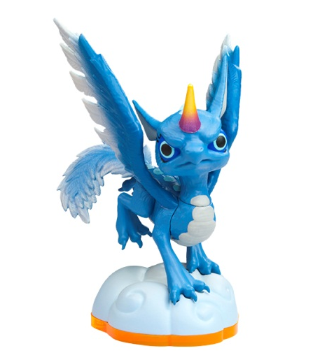

Element: Air

Character Type: Series 2

Bio: Whirlwind is an air dragon with unicorn ancestry – two species that could not be more opposite in nature, which made her never quite fit in with either group. Other dragons were envious of her beauty, while unicorns shunned her for her ability to fly. But Whirlwind found peace within the dark and stormy clouds, where she learned to harness the tempest power within her. Despite her turbulent youth, she was the first to defend both dragons and unicorns when the trolls began hunting them, unleashing her ferocity in a brilliant and powerful rainbow that could be seen throughout many regions of Skylands. From that day forward, evil-doers would quake when dark clouds brewed, and run from the rainbow that followed the storm.
Zook

Locked-And-Loaded!

Element: Life
Character Type: Series 2

Bio: Zook hails from a strange and unusual species called Bambazookers, who once lived their entire lives standing in place… until Zook discovered they could walk simply by stepping out of the mud. After that, he became a wandering hero, using his hand-carved bamboo tube as a bazooka that fires special explosive thorns. Campfire songs were even written about him. Now, Zook spends him
LightCore™ SKYLANDERS

Drobot

Blink and Destroy!

Element: Tech
Character Type: LightCore™ Skylander

Bio: Dragons are smart, but none so much as Drobot. He was born in the highest reaches of Skylands, where dragons spent all their time competing in aerial battles. But Drobot was more interested in taking things apart to see how they worked. While exploring one day, he came upon some mysterious technology, which he used to assemble a robotic suit. Features include laser beams that shoot from his eyes, flight enhancement technology, a vocal synthesizer that gives him a deep booming voice, and the ability to shoot spinning gears. With such power – more than most other dragons – Drobot joined the Skylanders to help protect the residents of Skylands.

Eruptor

Born To Burn!

Element: Fire

Character Type: LightCore™ Skylander

Bio: Eruptor is a force of nature, hailing from a species that lived deep in the underground of a floating volcanic island until a massive eruption launched their entire civilization to the surface. He’s a complete hot head – steaming, fuming, and quite literally erupting over almost anything. To help control his temper, he likes to relax in lava pools, particularly because there are no crowds.
Prism Break
The Beam is Supreme!
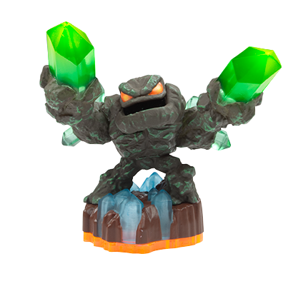
Element: Earth
Character Type: LightCore™ Skylander

Bio: Prism Break was once a fearsome rock golem who didn’t like to be disturbed. Then, an accidental cave-in left him buried underground. One hundred years later, a mining expedition digging for valuable jewels discovered him by chance with a well-placed blow from a pick axe – something Prism Break doesn’t talk about. After 100 years of solitude, he found that the pressure of the earth had transformed him emotionally as well as physically, turning his crude rocky arms into incredible gems with powerful energy. Grateful for being free of his earthly prison, Prism Break decided to put his new abilities to good use and dedicated himself to protecting Skylands.

